**1. Summary of lab work performed.**

In this lab, after watching videos on webcourses, I set up Educational Git, and set up a new git repository which can be found using the following link: <https://github.com/yahiaragab/CloudComputing>

Also, using VirtualBox (which I already had on my laptop because of the OS2 module in second year), I followed the lab instructions to set up Ubuntu on my laptop, and refreshed my memory on the commands that I will need to know to be able to navigate through it. I updated it, and downloaded git, and python3 on it and tested the latter to see if it works, and it did.

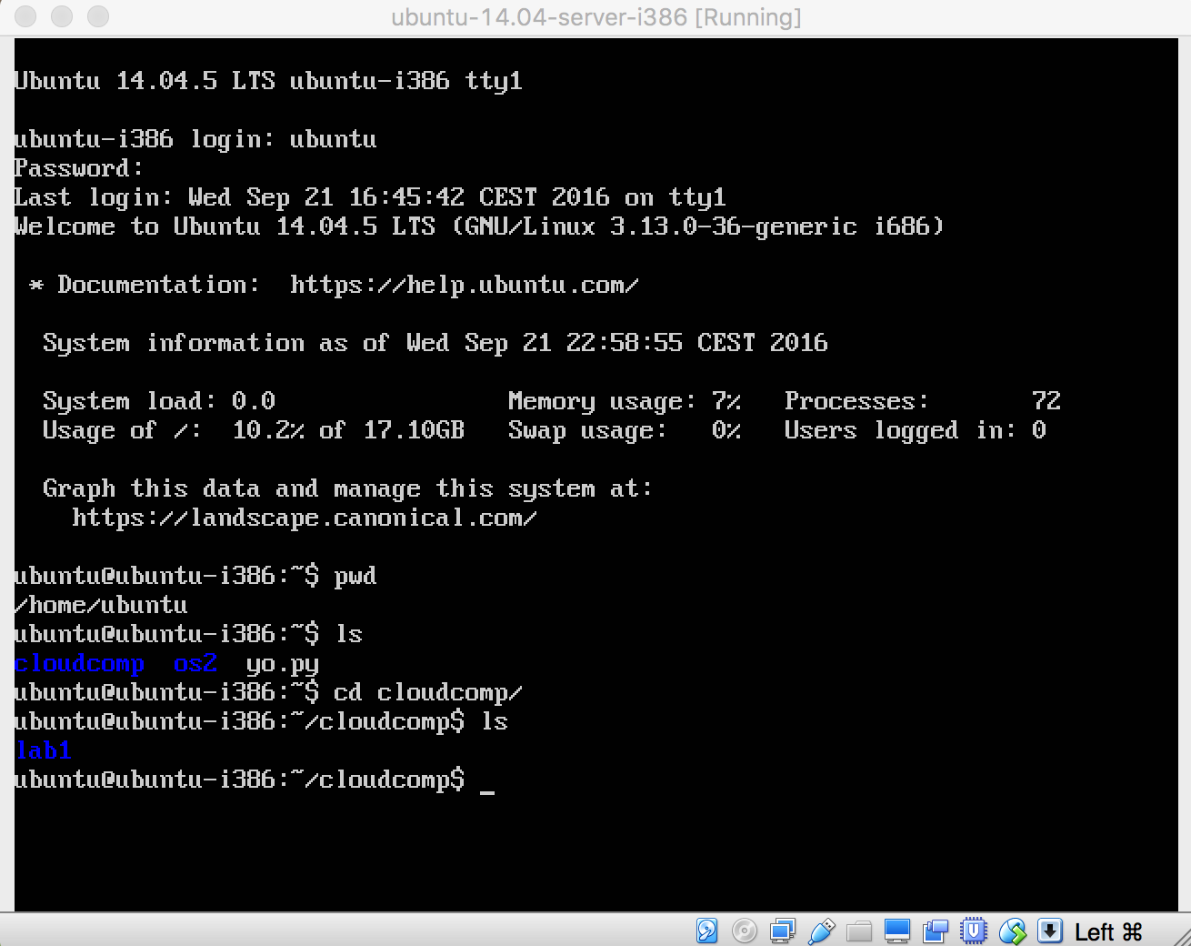

**2. What was learned.**

From watching the lecture videos, I learned about what a cloud is, about NIST, about security issues that we must consider, about the cloud in relation to business, some of the big names in the cloud business, such as Amazon, and openstack..etc.

Since I was away and could not attend the first lecture of this module, I wasn’t aware how this module was going to go, so I learned that in this lab. I learned minor python things, like file extensions, and a few methods. I refreshed my memory on using the Ubuntu terminal, as I mentioned in the previous question.

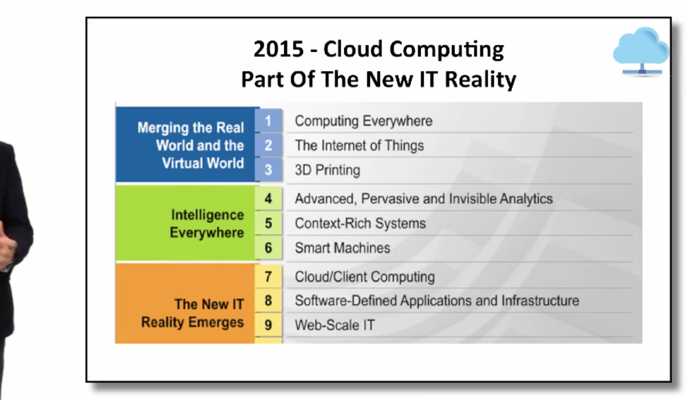

**3. Areas of difficulty.**

I wouldn’t say that I found something particularly difficult in this lab, but I was lost at the beginning because, as I mentioned earlier, I could not make it to the first lecture, so I wasn’t aware what I had to do or where to start. When I sorted everything out, and opened the lab documents, and videos, it was all good after that.

**4. What went well.**

For me getting Ubuntu to work went well, as I had already done everything last year, and I could tell that some people in the lab group were struggling to get it working.

**5. Any other comments.**

Nothing negative. The videos are very clear, and webcourses contains all the help. I haven’t done any Python in the past, so I hope we aren’t expect to know it before doing this module.

**GIT LINK:** <https://github.com/yahiaragab/CloudComputing>